Amazon ElastiCache

General ElastiCache Concepts

Fully managed implementations of two popular in-memory data stores – Redis and Memcached.

ElastiCache is a web service that makes it easy to deploy and run Memcached or Redis protocol-compliant server nodes in the cloud.

The in-memory caching provided by ElastiCache can be used to significantly improve latency and throughput for many read-heavy application workloads or compute-intensive workloads .

Best for scenarios where the DB load is based on Online Analytics Processing (OLAP) transactions.

Push-button scalability for memory, writes and reads.

In-memory key/value store – not persistent in the traditional sense.

Billed by node size and hours of use.

Elasticache EC2 nodes cannot be accessed from the Internet, nor can they be accessed by EC2 instances in other VPCs.

Cached information may include the results of I/O-intensive database queries or the results of computationally-intensive calculations.

Can be on-demand or reserved instances too (but not Spot instances).

Elasticache can be used for storing session state.

A node is a fixed-sized chunk of secure, network-attached RAM and is the smallest building block.

Each node runs an instance of the Memcached or Redis protocol-compliant service and has its own DNS name and port.

Failed nodes are automatically replaced.

Access to Elasticache nodes is controlled by VPC security groups and subnet groups (when deployed in a VPC).

Subnet groups are a collection of subnets designated for your Amazon ElastiCache Cluster.

You cannot move an existing Amazon ElastiCache Cluster from outside VPC into a VPC.

You need to configure subnet groups for Elasticache for the VPC that hosts the EC2 instances and the Elasticache cluster.

When not using a VPC, Amazon ElastiCache allows you to control access to your clusters through Cache Security Groups (you need to link the corresponding EC2 Security Groups).

Elasticache nodes are deployed in clusters and can span more than one subnet of the same subnet group.

A cluster is a collection of one or more nodes using the same caching engine.

Applications connect to Elasticache clusters using endpoints.

An endpoint is a node or cluster’s unique address.

Maintenance windows can be defined and allow software patching to occur.

There are two types of ElastiCache engine:

* Memcached – simplest model, can run large nodes with multiple cores/threads, can be scaled in and out, can cache objects such as DBs.
* Redis – complex model, supports encryption, master / slave replication, cross AZ (HA), automatic failover and backup/restore.

Use Cases

The following table describes a few typical use cases for ElastiCache:

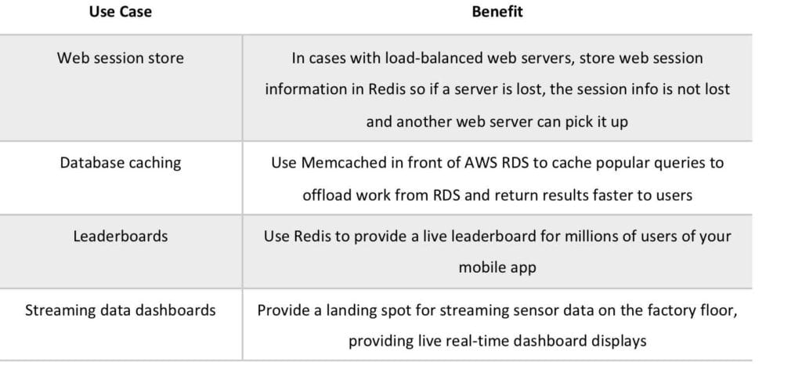

The table below describes the requirements that would determine whether to use the Memcached or Redis engine:

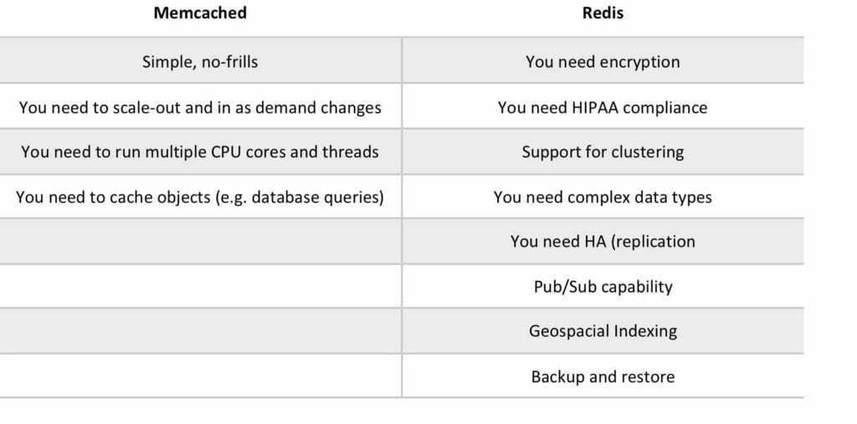

Memcached

Not persistent.

Cannot be used as a data store.

Supports large nodes with multiple cores or threads.

Scales out and in, by adding and removing nodes.

Ideal front-end for data stores (RDS, Dynamo DB etc.).

Use cases:

* Cache the contents of a DB.
* Cache data from dynamically generated web pages.
* Transient session data.
* High frequency counters for admission control in high volume web apps.

Max 100 nodes per region, 1-20 nodes per cluster (soft limits).

Can integrate with SNS for node failure/recovery notification.

Supports auto-discovery for nodes added/removed from the cluster.

Scales out/in (horizontally) by adding/removing nodes.

Scales up/down (vertically) by changing the node family/type.

Does not support multi-AZ failover or replication.

Does not support snapshots.

You can place nodes in different AZs.

With ElastiCache Memcached each node represents a partition of data and nodes in a cluster can span availability zones:

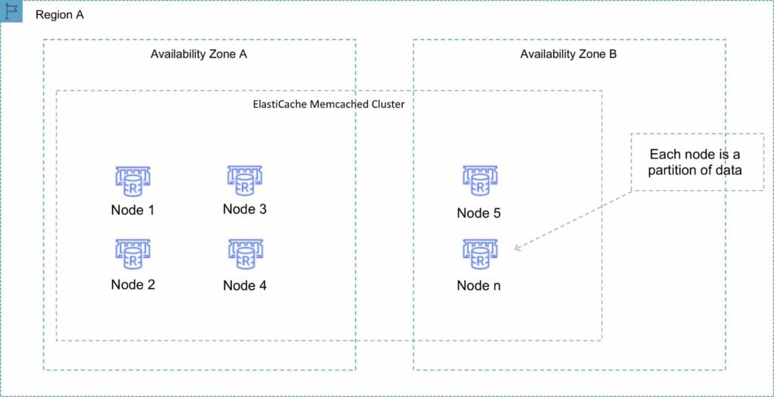

Redis

Data is persistent.

Can be used as a datastore.

Not multi-threaded.

Scales by adding shards, not nodes.

A Redis shard is a subset of the cluster’s keyspace, that can include a primary node and zero or more read-replicas.

Supports automatic and manual snapshots (S3).

Backups include cluster data and metadata.

You can restore your data by creating a new Redis cluster and populating it from a backup.

Supports master/slave replication.

During backup you cannot perform CLI or API operations on the cluster.

Automated backups are enabled by default (automatically deleted with Redis deletion).

You can only move snapshots between regions by exporting them from Elasticache before moving between regions (can then populate a new cluster with data).

Multi-AZ is possible using read replicas in another AZ in the same region.

Clustering mode disabled:

* You can only have one shard.
* One shard can have one read/write primary node and 0-5 read only replicas.
* You can distribute the replicas over multiple AZs in the same region.
* Replication from the primary node is asynchronous.

A Redis cluster with cluster mode disabled is represented in the diagram below:

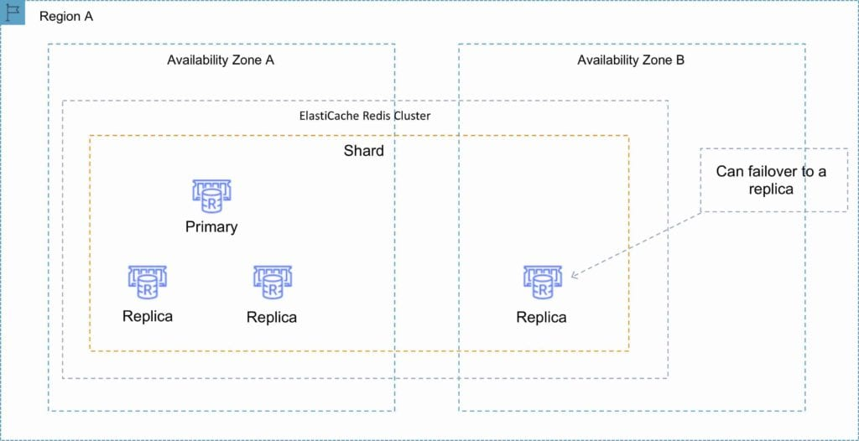

Clustering mode enabled:

* Can have up to 15 shards.
* Each shard can have one primary node and 0-5 read only replicas.
* Taking snapshots can slow down nodes, best to take from the read replicas.

A Redis cluster with cluster mode enabled is represented in the diagram below:

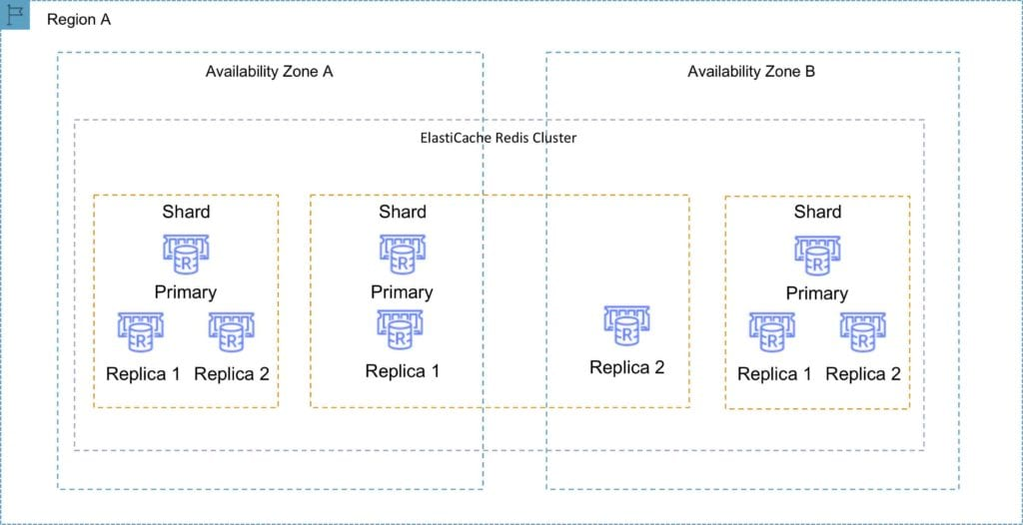

Multi-AZ failover:

* Failures are detected by Elasticache.
* Elasticache automatically promotes the replica that has the lowest replica lag.
* DNS records remain the same but point to the IP of the new primary.
* Other replicas start to sync with the new primary.

You can have a fully automated, fault tolerant Elasticache-Redis implementation by enabling both cluster mode and multi-AZ failover.

The following table compares the Memcached and Redis engines:

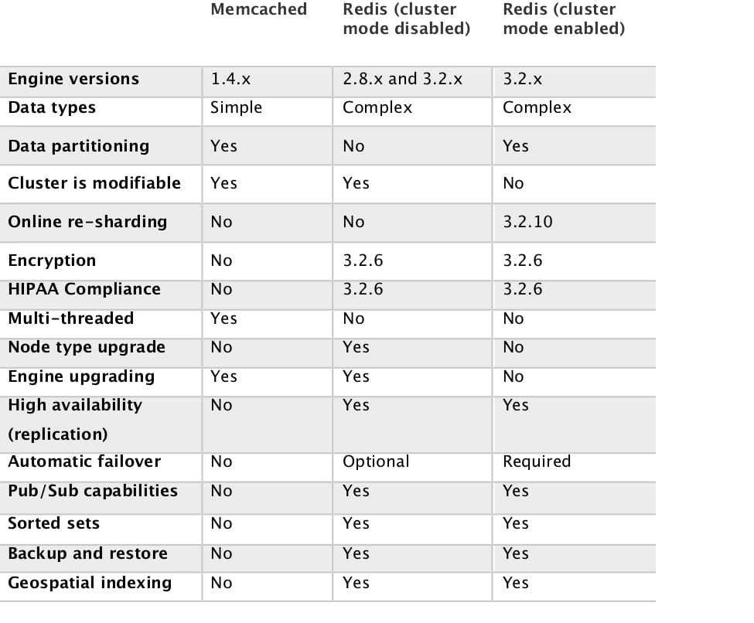

Charges

Pricing is per Node-hour consumed for each Node Type.

Partial Node-hours consumed are billed as full hours.

There is no charge for data transfer between Amazon EC2 and Amazon Elasticache within the same Availability Zone.

High Availability for ElastiCache

Memcached:

* Because Memcached does not support replication, a node failure will result in data loss.
* Use multiple nodes to minimize data loss on node failure.
* Launch multiple nodes across available AZs to minimize data loss on AZ failure.

Redis:

* Use multiple nodes in each shard and distribute the nodes across multiple AZs.
* Enable Multi-AZ on the replication group to permit automatic failover if the primary nodes fails.
* Schedule regular backups of your Redis cluster.